# Required Components

|  |  |
| --- | --- |
| **2**  **1**    **3**      **4**    **5** | **BOM**   1. Wireless Relay Remote Control Switch 2. Battery Holder for 3 AA batteries 3. 3x AA batteries 4. 2x Latching Switches 5. 3.5 mm Extension Cable |

# Required Tools

* Small Phillips screwdriver
* Soldering Iron and Solder
* Wire strippers

# Required Personal Protective Equipment (PPE)

* Safety Glasses

# Assembly Instructions

## Preparation

### Cut Cable

With the 3.5 mm male to female cable, cut the cord so that the end with the jack (male end) is 60 cm (2 ft) long and the end with the plug (female end) is 30 cm (1 ft) long. If your cable is longer than 90 cm (3 ft), you can discard the remainder of the cable.

|  |
| --- |
| Scissors outlinea picture of the 3.5mm male ot female cable cut in 2 pieces |

### Strip Cable Ends

Once the cable is cut, strip both the cut ends of the female and male wires about 2 cm. If there are still two wires enclosed in plastic, the individual wires will also have to be stripped approximately 0.5 cm. Twist the wires so that they don’t get mixed up.

|  |
| --- |
| a picture of the end of one of the wires stripped |

## Receiver

### Remove Enclosure

Open and set aside the case around the receiver.

|  |
| --- |
| a picture of a small white plastic receiver opened up with electronics and wiring showing |

### Desolder wires

Desolder all 4 wires from the bottom of the receiver. Set these wires aside for later use.

|  |  |  |
| --- | --- | --- |
| |  |  | | --- | --- | | a picture of 4 wires soldered to the receiver | a picture showing the receiver with all wires desoldered | |

### Trim battery holder wires

Cut off approximately 8 cm from the red wire from the battery terminal. Strip off 0.5 cm to expose the wire.

|  |
| --- |
| Scissors outlinea picture of a black battery compartment for 3 AA batteries with 2 wires |

### Solder one battery holder lead to receiver PCB

Solder the other end of the red wire on the battery compartment to the V+ pin on the bottom of the receiver.

|  |
| --- |
| a picture of the battery compartment being soldered to the receiver board |

### Solder other battery holder lead to On/Off Switch

Solder the other end of black wire on the battery compartment to one leg of a latching switch.

|  |
| --- |
| a picture of one of the wires from the battery compartment soldered to a small latching switch |

### Prep wire

Grab one of the 4 wires that were desoldered earlier from the receiver. Strip 0.5 cm from the end of each wire.

|  |
| --- |
| a picture of a short wire stripped at both ends |

### Solder wire to On/Off Switch

Solder one end of the wire to the other leg of the same latching switch. This will be the On/Off switch for the device.

|  |
| --- |
| a picture of the latching switch soldered to 2 wires |

### Solder Wire from On/Off Switch to Receiver PCB

Solder the other end of the wire to the V- pin on the bottom of the receiver.

|  |
| --- |
| a picture of 2 wires soldered to the bottom of the green receiver board |

### Insert Cable into Receiver Enclosure

Thread the stripped ends of the male cable through the hole in the 3D print labeled Device Output.

|  |
| --- |
| a picture of the male end of the 3.5mm cable threaded through a hole in the base of the purple 3d printed receiver |

### Knot Cable

Tie a knot in the end of the wire approximately 2-3 from the ends of the stripped wires.

|  |
| --- |
| a picture of a stripped wire with a knot tied in the cable |

### Solder 3.5 mm cable to Receiver PCB

Solder the two ends of the wire to the “NO” and “COM” pins on the bottom of the receiver.

|  |
| --- |
| A picture of the 3.5mm cable soldered to the pins on the bottom of the green receiver |

### Prep Mode Switch Wires

Grab 2 more of the wires you previously desoldered and set aside. Strip 0.5 cm from each end of the wire.

|  |
| --- |
| a picture of two yellow stripped wires |

### Solder Mode Switch Wires to Mode Switch

Solder one end of each of the wires to the legs on the second latching switch. This will be the mode button for the device.

|  |
| --- |
| a picture of the yellow wires soldered to another latching switch |

### Solder Mode Switch Wires to Receiver PCB

Solder the other two ends of the wires to the two legs of the switch located on the receiver as shown.

|  |
| --- |
| a picture of the other end of the yellow wires being soldered to a small white switch on the receiver board |

### Insert Components into Receiver Enclosure

Place the battery compartment and the receiver in the 3D printed base as shown.

|  |
| --- |
| a picture of the battery compartment and receiver being placed into the purple 3d printed base |

### Insert On/Off Switch into Receiver Enclosure

Locate the switch soldered in Step 9 known as the On/Off Switch. While depressing the switch, slide it vertically down into the slot labelled “ON/OFF” on the print.

|  |
| --- |
| a picture of the on/off latching switch in place in the purple 3d printed base |

### Insert Mode Switch into Receiver Enclosure

Do the same with the second latching switch. This time it will slide into the slot labelled “MODE”

|  |
| --- |
| a picture of the mode button in place in the 3d printed base |

### Insert Batteries into Battery Holder

Insert 3 AA batteries into the battery holder. If the receiver starts blinking red, press the “MODE” button and it should turn off.

|  |
| --- |
| a picture of 3 AA batteries placed in the battery compartment in the receiver |

## Transmitter

### Open Transmitter Case

Remove the three screws from the back of the remote.

|  |
| --- |
| a picture of a small black remote similar to a car remote |

### Disassemble Transmitter

Remove and set aside the remote casing.

|  |
| --- |
| a picture of the black remote opened up |

### Insert Cable into Transmitter Enclosure

With the female end of the 3.5 mm cable, thread the wire stripped end of the wire through the hole in the smaller 3D printed base labelled “Switch Input”.

|  |
| --- |
| a picture of a stripped 3.5mm cable threaded through a hole in the transmitter |

### Solder Cable to Transmitter PCB

Solder the two stripped wires to each side of the switch located in the middle of the board of the transmitter.

|  |
| --- |
| a picture of the wire soldered to the switch of the transmitter |

### Insert Transmitter PCB into Transmitter Enclosure

Place the transmitter in the 3D printed base as shown.

|  |
| --- |
| a picture of the transmitter placed in the purple 3d printed base |

## Testing

### Attach Assistive Switch to Transmitter

Test the transmitter and receiver before putting on the enclosure covers. Plug a 3.5 mm switch into the female end of the 3.5 mm cable (on the transmitter).

|  |
| --- |
| a picture of a round red assistive switch plugged into the transmitter |

### Attach Receiver to Output Device

From the receiver, connect the 3.5 mm male plug to the 3.5 mm connection on an output device such as a switch adapted toy.

|  |
| --- |
| a picture of a switch adapted blue whale bubble blower plugged into the receiver |

### Test the Device

Activate the assistive switch. The toy should activate. If nothing happens, press the “ON/OFF” button on the receiver and try again. The toy might not activate yet but there will be a “clicking sound and a red-light flash

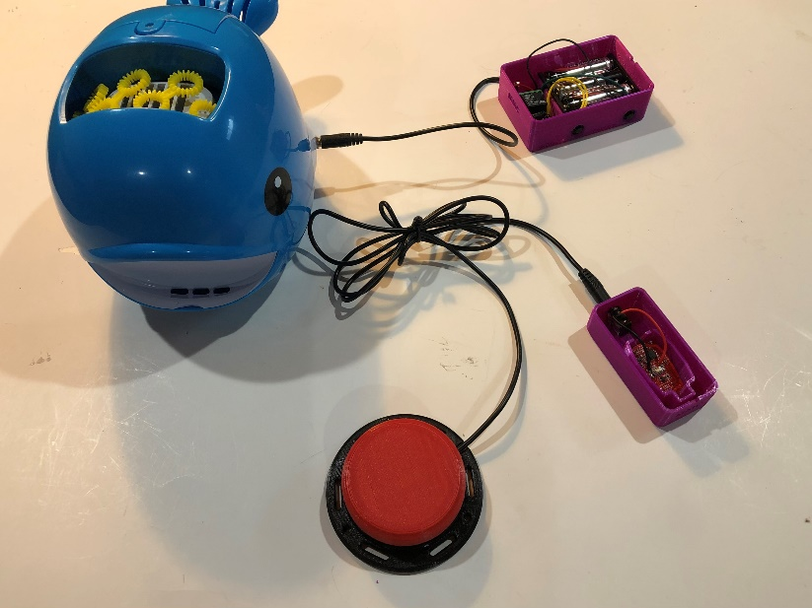

|  |
| --- |
|  |

## Final Assembly

### Add Covers to Enclosures

Once the devices are working, add the cover to each enclosure by snapping them in to place.

|  |
| --- |
| a picture of the final product of the purple transmitter and receiver |

## Setting Activation Mode

### Change Activation Mode

There are several different modes offered on the receiver. If you press the “MODE” button, the device should start to flash. It will do one flash, pause, two flashes, pause, 3 flashes, pause, all the way up to 7 flashes. To select a mode, press the “MODE” button again after you see the number of flashes for the setting you want. For example, if you want to use to momentary switch function, press the mode button, then wait for the red light to flash twice in a row, then press the mode button again. The following is a guide to explain the different modes:

1 flash = What seems to be an infinite latch? It does not appear to be useful and would recommend not using it.

2 flashes = momentary switch. The output device will turn off about 0.5 seconds after the user stops pressing the switch.

3 flashes = latching switch. It will stay on until you press the assistive switch again to turn it off.

4 flashes = switch latches for 10 seconds and then turns off.

5 flashes = switch latches for 1 minute and then turns off.

6 flashes = switch latches for 5 minutes and then turns off.

7 flashes = An “error”. Avoid using this setting. If you accidentally set the device to the 7th setting, it will not do anything. The device will have to be resynced by pressing the mode button twice quickly until the red light stays on. Next, click the assistive switch. Then, press the mode button again to pick the mode you want. The device should work again once this is complete.